Name : MUHAMMAD MUBASHAR ALI

Student ID : BSIET02213012

Subject : Object Oriented Programming .

Lab : 06

Example # 01

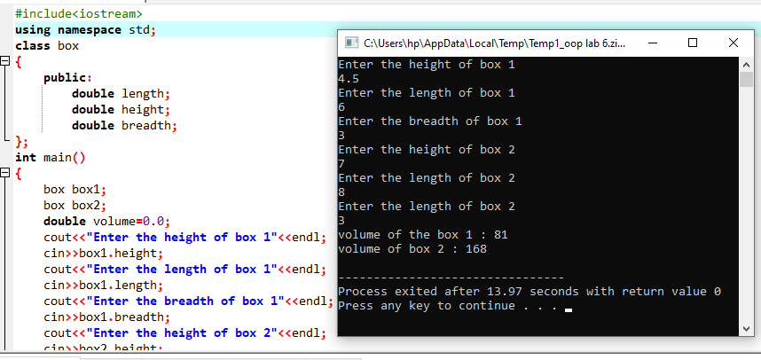

Example #02

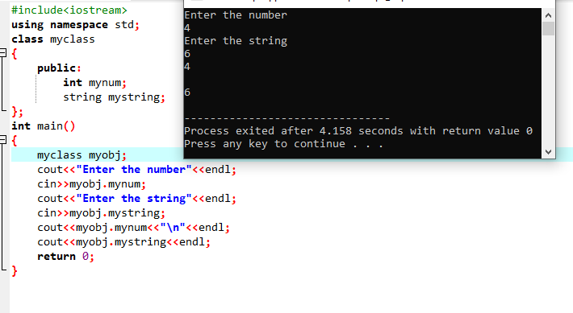

Example # 03

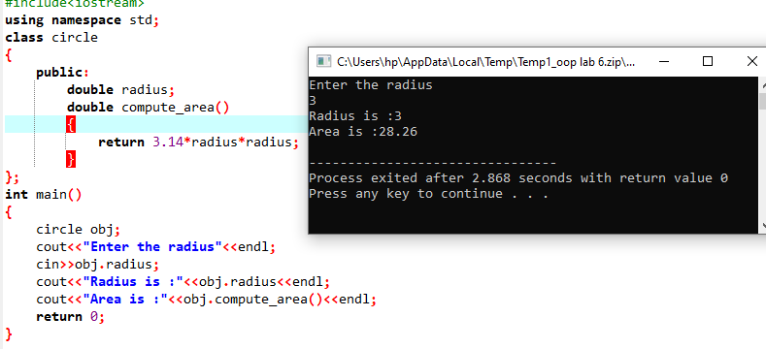

Example # 04

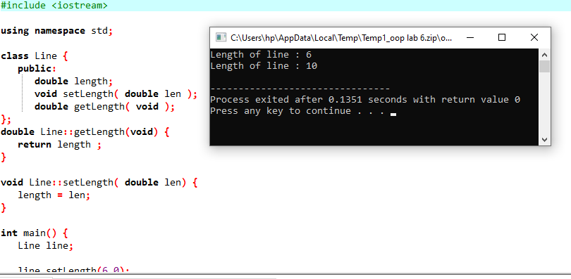

Example # 05

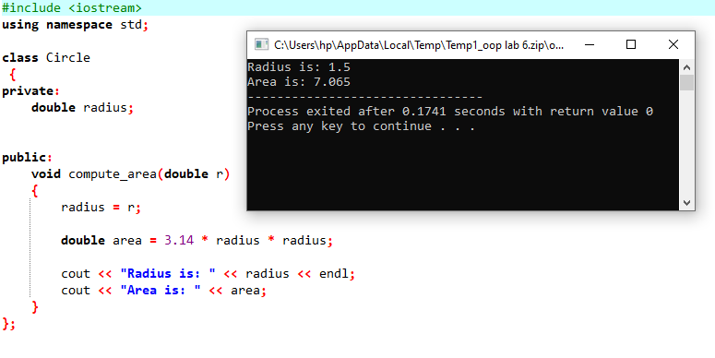

Example # 06

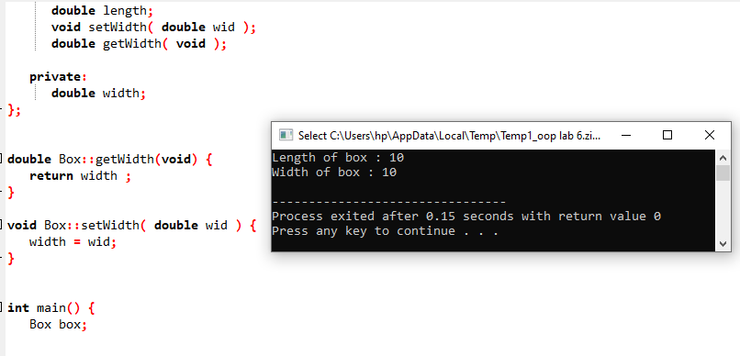

Example # 07

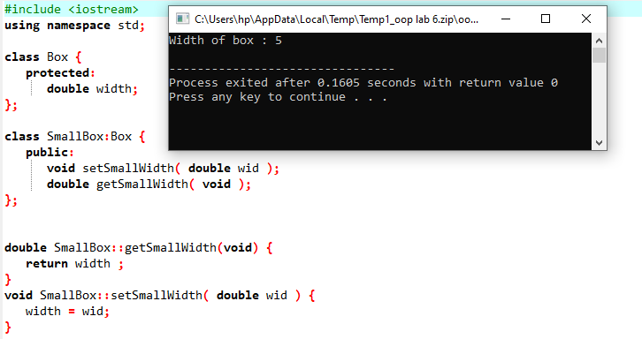

Example # 08

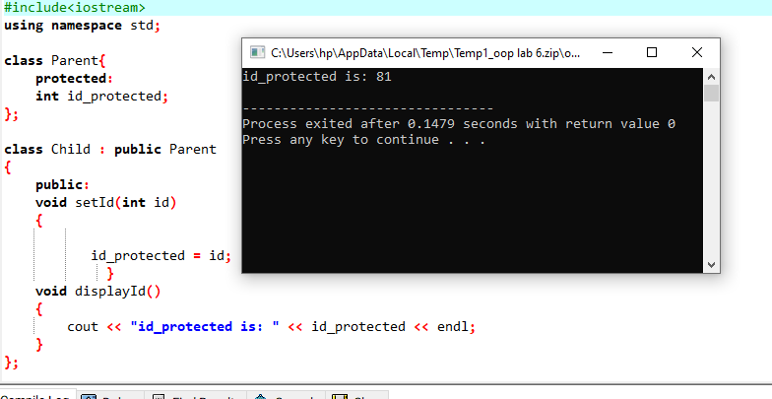

Review Questions

Question # 01

Solved all lab exercise questions and check their output by your lab instructor?

Answer

All done.

Question # 02

Write a C++ program to display Student details using classes. Enter the name of student registration no, batch no and semester on run time. Input function is used to input data of student and display function is used to print the result ?

Answer

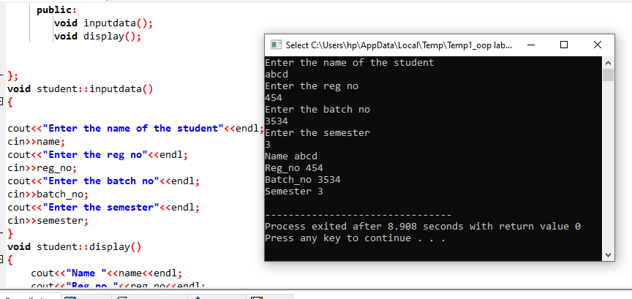

Question # 03

Write a C++ program to print the sum of first 100 odd numbers using class?

Answer

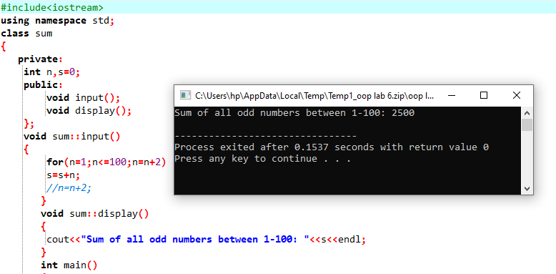

Question # 04

Compute the output of the following program and explain the each line of code working.?

Answer

